Elicia Pluymers

Final Project Documentation

NEWM-N230

**Life though Memories**

[Game Video Link](https://drive.google.com/file/d/1ZC9OdsZ3K9vW-xqZe9ZAH0wQBpX8v0Dj/view?usp=sharing)

**Game Premise**

* You begin in an apartment and quickly realize you are a ghost, but have no idea who you are.
* While moving through the apartment and interacting with objects, you learn about the people that live in the apartment.
* Once you are able to get out of the apartment, but enter a circular hallway and find that each apartment door has the same apartment number.
* Each apartment opens up into a different time in the same apartment, through which you learn more about who you could potentially be and why you might have died.
* You interact with the story by progressing through the rooms and listening to different audio encounters that occurred in each static space.

**Player Goal**

* Navigate the world and find out who you are and why you died.
* Finish the story, to find out which character you are.

**Game Mechanics**

* The game is a story where the player progresses through listening to past conversation, learning more about the people that live in the apartment by traveling through the various rooms and finding bits of the story as they go.

The Interface

Movement - WASD

Camera Movement - Mouse

Pause Game - P

Go through doors – E

Inspect an area - Q

**Game Design Choices**

* The entire room is static and most of the game play involves visual changes, and audio clips, heard when certain areas are investigated.
* Each apartment door opens and more of the story pieces are revealed as the player continues through the game.
* The player begins the game seeing only in grey scale and as they view more parts of the story the colors bleed back into the apartment.
* There are a total of 8 rooms and each room represents a portion of time in the player’s life. I adjusted the content of the various apartments to reflect changes that would occur over the progress of time as the rooms span a 14 year gap of time.

**Game Atmosphere**

* The game should not be meant to scare the player, they are a ghost, things will not harm them.
* The main puzzle of the game is finding out which room holds the next part of the story to progress the game along.

**Characters**

* Since the player doesn’t know who they are or anything about themselves and each room is a frozen point in space the characters are revealed in static poses in the room as events unfold in the rooms.
* This is also a good indicator to the player that they have already visited a specific area though they can return to listen to the audio again.

Character Inspiration

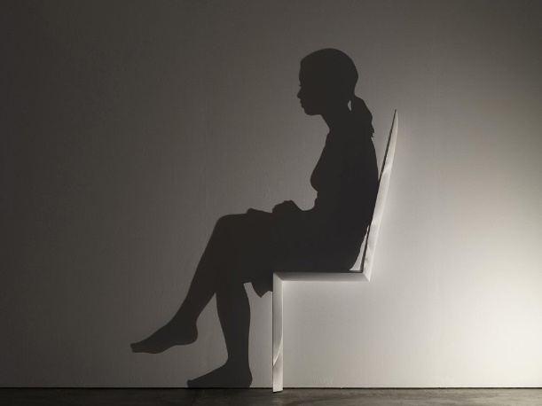 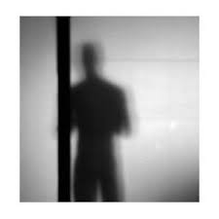

[Image Link](https://th-thumbnailer.cdn-si-edu.com/fksbh4Gq-MThbYel33Jaa_A2hwY=/1000x750/filters:no_upscale()/https:/tf-cmsv2-smithsonianmag-media.s3.amazonaws.com/filer/47/29/4729264c-4328-456c-ad6e-8b7efb01b244/may2018_a08_prologue.jpg) [Image Link](https://www.google.com/url?sa=i&url=https%3A%2F%2Ffineartamerica.com%2Ffeatured%2Fshadow-figure--a-rey.html&psig=AOvVaw2L3sb4svy20acfkF6aU_dQ&ust=1646364151847000&source=images&cd=vfe&ved=0CAsQjRxqFwoTCIDp7sr-qPYCFQAAAAAdAAAAABAj)

Appartment and Hallway Inspiration

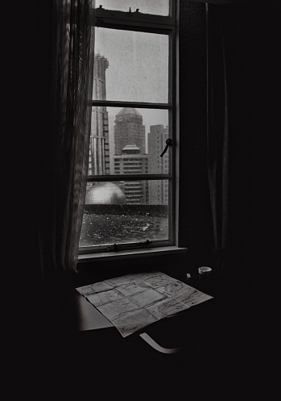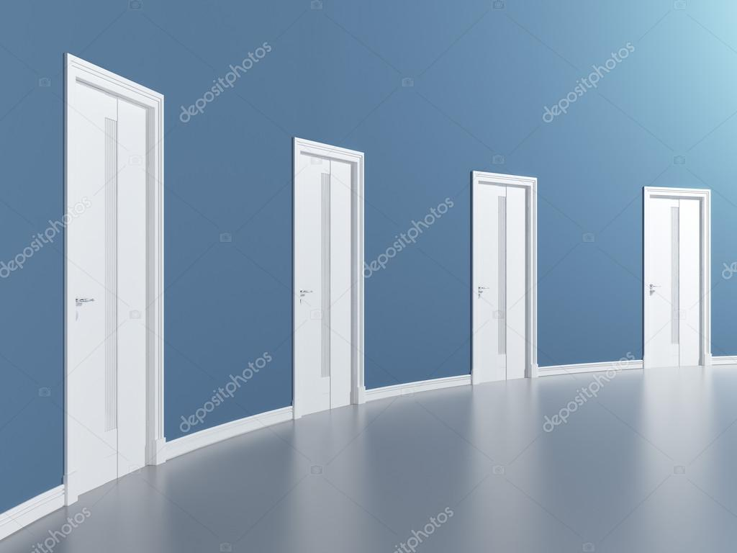

[Image Link](https://www.google.com/imgres?imgurl=https%3A%2F%2Fmedia.istockphoto.com%2Fphotos%2Fview-from-the-window-to-the-skyscrapers-of-shanghai-there-is-a-map-on-picture-id1291245533%3Fk%3D20%26m%3D1291245533%26s%3D170667a%26w%3D0%26h%3DbNBonk_DXIXpz_hCBUf1DZl_qakwEof4R_hcrttqNsU%3D&imgrefurl=https%3A%2F%2Funsplash.com%2Fphotos%2FqteVKRUbPqw&tbnid=MPD79omohOrHRM&vet=12ahUKEwiY_pbX_qr2AhX0AJ0JHe3aBEwQMygWegUIARDgAQ..i&docid=Nxnl_Hp5eVnQxM&w=349&h=497&itg=1&q=grey%20scale%20dawn%20light%20appartment&ved=2ahUKEwiY_pbX_qr2AhX0AJ0JHe3aBEwQMygWegUIARDgAQ) [Image Link](https://st.depositphotos.com/1765561/3096/i/950/depositphotos_30966597-stock-photo-doors-in-blue-round-room.jpg)

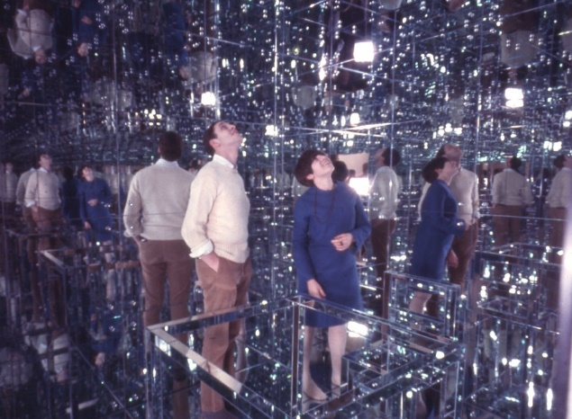 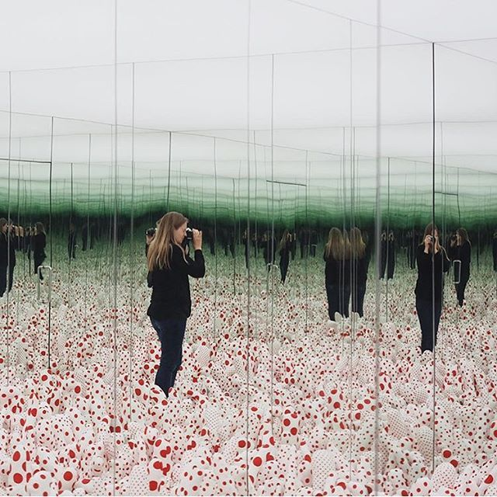

[Image Link](https://www.albrightknox.org/sites/default/files/styles/fixed_height_medium/public/Lucas%20Samaras%20Mirrored%20Room%20Members%20Preview_1966.12.15_002.jpg?itok=E-Q5jFL-) [Image Link](https://i.pinimg.com/736x/3a/73/b8/3a73b850af9f4cac4059d81bd513ac14--infinity-mirror-room-infinity-room.jpg)

**In Game Assets Acquired**

**Characters**

Mom: Mixamo Character Roth

Dad: Mixamo Character Brian

Son: Mixamo Character Remy

[Dog - Golden Retriever in Characters - UE Marketplace](https://www.unrealengine.com/marketplace/en-US/product/dog-golden-retriever)

**Sounds**

[Freesound - "Original Ambience Sound Unaltered" by SeanSecret](https://freesound.org/people/SeanSecret/sounds/251652/)

[Freesound - "shower.mp3" by geodylabs](https://freesound.org/people/geodylabs/sounds/122810/)

[Freesound - "Wooden Door.wav" by vero.marengere](https://freesound.org/people/vero.marengere/sounds/450300/)

[Freesound - "washing-dishes.wav" by cyoung510](https://freesound.org/people/cyoung510/sounds/535534/)

[Freesound - "dog eating.wav" by kwahmah_02](https://freesound.org/people/kwahmah_02/sounds/245039/)

[Freesound - "Dog drinking water" by Marnenagel](https://freesound.org/people/Marnenagel/sounds/408493/)

[Freesound - "Keyboard Clicking (Typing)" by Spencer_Eisenhauer](https://freesound.org/people/Spencer_Eisenhauer/sounds/611834/)

[Freesound - "forks_knifes_dish.m4a" by Swi3rszczu](https://freesound.org/people/Swi3rszczu/sounds/437310/)

[Freesound - "Small Dog Bark 02" by noctaro](https://freesound.org/people/noctaro/sounds/242413/)

**Objects**

[Simple Door free 3D model | CGTrader](https://www.cgtrader.com/free-3d-models/architectural/door/simple-door--2)

[Wooden Door free 3D model | CGTrader](https://www.cgtrader.com/free-3d-models/architectural/door/wooden-door-d13)

[Simple door free 3D model | CGTrader](https://www.cgtrader.com/free-3d-models/interior/other/simple-door-3bf80f4b-c7cf-4158-b6a9-210827491073)

[2 Doors French Refrigerator PBR - Low Poly free VR / AR / low-poly 3D model | CGTrader](https://www.cgtrader.com/free-3d-models/interior/kitchen/2-doors-french-refrigerator-pbr-low-poly-8af3eaf1-6d19-401a-b5f2-afbb2d97e267)

[Kitchen Sink free VR / AR / low-poly 3D model | CGTrader](https://www.cgtrader.com/free-3d-models/furniture/kitchen-furniture/kitchen-sink-795a727c-29bc-4d88-a5e9-0d61a3ffadc4)

[Modern Smart Stove free VR / AR / low-poly 3D model | CGTrader](https://www.cgtrader.com/free-3d-models/furniture/kitchen-furniture/modern-smart-stove)

[Tap and Cuba free 3D model | CGTrader](https://www.cgtrader.com/free-3d-models/interior/bathroom/tap-and-cuba)

[Marble Bathroom Sink free VR / AR / low-poly 3D model | CGTrader](https://www.cgtrader.com/free-3d-models/furniture/other/bathroom-sink-07b46f36-c6ba-41d5-ad60-9475c96988fc)

[Rigged Toilet free VR / AR / low-poly 3D model rigged | CGTrader](https://www.cgtrader.com/free-3d-models/interior/bathroom/rigged-toilet)

[Soaking Bath Tub Right Drain free 3D model | CGTrader](https://www.cgtrader.com/free-3d-models/interior/bathroom/soaking-bath-tub-right-drain)

[Kids Bed - Cama infantil individual free 3D model | CGTrader](https://www.cgtrader.com/free-3d-models/furniture/bed/kids-bed-cama-infantil-individual)

[Tobacco Wood Nightstand free VR / AR / low-poly 3D model | CGTrader](https://www.cgtrader.com/free-3d-models/furniture/table/rustic-wood-nightstand)

[Free bed molteni model - TurboSquid 1554756](https://www.turbosquid.com/3d-models/bed-molteni-model-1554756)

[Nightstand free VR / AR / low-poly 3D model | CGTrader](https://www.cgtrader.com/free-3d-models/furniture/cabinet/nightstand-dca7fe0d-4658-403d-b0df-d68e34f7df0c)

[Fermo Double Dresser free VR / AR / low-poly 3D model | CGTrader](https://www.cgtrader.com/free-3d-models/furniture/cabinet/fermo-double-dresser)

[Black Bed free 3D model | CGTrader](https://www.cgtrader.com/free-3d-models/interior/bedroom/black-bed) [Dresser Six Drawers free 3D model | CGTrader](https://www.cgtrader.com/free-3d-models/furniture/cabinet/dresser-six-drawers)

[Dresser free 3D model | CGTrader](https://www.cgtrader.com/free-3d-models/furniture/cabinet/dresser--11) [Dresser Three Drawers A free 3D model | CGTrader](https://www.cgtrader.com/free-3d-models/furniture/cabinet/dresser-three-drawers-a)

[Simple Office Desk free VR / AR / low-poly 3D model | CGTrader](https://www.cgtrader.com/free-3d-models/interior/interior-office/simple-office-desk)

[desk chair free 3D model | CGTrader](https://www.cgtrader.com/free-3d-models/furniture/chair/desk-chair-9993a626-d19a-460c-a09b-f0f3e31638bb)

[free dining table benchwright fixed 3d model](https://www.turbosquid.com/3d-models/free-dining-table-benchwright-fixed-3d-model/783424)

[free max model table](https://www.turbosquid.com/3d-models/free-max-model-table/854826) [free 3ds model kitchen cabinet corner](https://www.turbosquid.com/3d-models/free-3ds-model-kitchen-cabinet-corner/755693)

[free 3ds mode kitchen wardrobe](https://www.turbosquid.com/3d-models/free-3ds-mode-kitchen-wardrobe/763178)

[Free 3D Wooden Stool Low-poly model - TurboSquid 1806860](https://www.turbosquid.com/3d-models/3d-wooden-stool-lowpoly-model-1806860)

[Free 3D simple chair kitchen dining room - TurboSquid 1270104](https://www.turbosquid.com/3d-models/3d-simple-chair-kitchen-dining-room-1270104)

[Free 3D model High Poly Wooden Chair - TurboSquid 1795945](https://www.turbosquid.com/3d-models/3d-model-high-poly-wooden-chair-1795945)

[3D wooden chair - TurboSquid 1327598](https://www.turbosquid.com/3d-models/3d-wooden-chair-1327598)

[3D wooden chair - TurboSquid 1327598](https://www.turbosquid.com/3d-models/3d-wooden-chair-1327598)

[samsung led tv max free](https://www.turbosquid.com/3d-models/samsung-led-tv-max-free/749208) [Tv 3D model - TurboSquid 1709038](https://www.turbosquid.com/3d-models/tv-3d-model-1709038)

[Tv 3D model - TurboSquid 1709038](https://www.turbosquid.com/3d-models/tv-3d-model-1709038) [3D tv table - TurboSquid 1378058](https://www.turbosquid.com/3d-models/3d-tv-table-1378058)

[Free 3D table2 - TurboSquid 1433435](https://www.turbosquid.com/3d-models/3d-table2-1433435) [free sofa 3d model](https://www.turbosquid.com/3d-models/free-sofa-3d-model/1073499)

[Free 3D model Low Poly Sofa - TurboSquid 1741699](https://www.turbosquid.com/3d-models/3d-model-low-poly-sofa-1741699)

[Free 3D model Low Poly Sofa - TurboSquid 1741699](https://www.turbosquid.com/3d-models/3d-model-low-poly-sofa-1741699)

[Pears poster in black frame free 3D model | CGTrader](https://www.cgtrader.com/free-3d-models/interior/kitchen/pears-poster)

[window 3d 3ds](https://www.turbosquid.com/3d-models/window-3d-3ds/1066625) [Golden teak fine wood PBR texture seamless 22010](https://www.sketchuptextureclub.com/textures/architecture/wood/fine-wood/medium-wood/golden-teak-fine-wood-pbr-texture-seamless-22010)

[Bunk Beds free 3D model | CGTrader](https://www.cgtrader.com/free-3d-models/furniture/bed/bunk-beds--3)

[Free Dog Bowl model - TurboSquid 1805814](https://www.turbosquid.com/3d-models/dog-bowl-model-1805814)

[3D modern ceiling fan - TurboSquid 1631426](https://www.turbosquid.com/FullPreview/1631426)

[fan lamp animation obj free](https://www.turbosquid.com/FullPreview/1043219)

[free microwave blender 3d model](https://www.turbosquid.com/3d-models/free-microwave-blender-3d-model/669210)

[Free Pet bed 3D model - TurboSquid 1733474](https://www.turbosquid.com/3d-models/pet-bed-3d-model-1733474)

[Free 3D table accent rest - TurboSquid 1386510](https://www.turbosquid.com/3d-models/3d-table-accent-rest-1386510)

[Free table model - TurboSquid 1543170](https://www.turbosquid.com/FullPreview/1543170)

[Vintage furniture coffee table 3D model - TurboSquid 1585204](https://www.turbosquid.com/FullPreview/1585204)

[Free 3D model collier webb console - TurboSquid 1498243](https://www.turbosquid.com/3d-models/3d-model-collier-webb-console-1498243)

[Free 3D model phone office - TurboSquid 1568608](https://www.turbosquid.com/FullPreview/1568608)

[Free Tabletop Clock model - TurboSquid 1737300](https://www.turbosquid.com/3d-models/tabletop-clock-model-1737300)

[Free printer lcd 3D model - TurboSquid 1453968](https://www.turbosquid.com/3d-models/printer-lcd-3d-model-1453968)

[Indoor plants 3D model - TurboSquid 1372214](https://www.turbosquid.com/3d-models/indoor-plants-3d-model-1372214)

[Free flower vase 3D - TurboSquid 1567885](https://www.turbosquid.com/FullPreview/1567885)

[High Poly Christmas Tree free 3D model | CGTrader](https://www.cgtrader.com/free-3d-models/interior/living-room/high-poly-christmas-tree)

[CHRISTMAS PACK free 3D model | CGTrader](https://www.cgtrader.com/free-3d-models/plant/other/christmas-pack-0dc0a922-987a-495e-a969-e2ecd6537da6)

[Free 3D asta lg1 - TurboSquid 1656746](https://www.turbosquid.com/FullPreview/1656746)

[cook voi nuoc free 3D model | CGTrader](https://www.cgtrader.com/free-3d-models/interior/bathroom/cook-voi-nuoc)

[Free 3D wall cylinder light - TurboSquid 1187498](https://www.turbosquid.com/FullPreview/1187498)

[Low-poly 125 VAC Wall Outlet - USA free VR / AR / low-poly 3D model | CGTrader](https://www.cgtrader.com/free-3d-models/household/other/lo-poly-125-vac-wall-outlet-us)

[Light Switch free VR / AR / low-poly 3D model | CGTrader](https://www.cgtrader.com/free-3d-models/architectural/decoration/light-switch-c7eff951-c1f2-45ce-8243-c366340d8bdc)

[Board skateboard 3D model - TurboSquid 1274602](https://www.turbosquid.com/FullPreview/1274602)

[kitchen stuff x free](https://www.turbosquid.com/FullPreview/750182)

[Bathtub with Shower free VR / AR / low-poly 3D model | CGTrader](https://www.cgtrader.com/free-3d-models/furniture/other/bathtub-with-shower)

[Free playstation play sony 3D - TurboSquid 1419763](https://www.turbosquid.com/3d-models/playstation-play-sony-3d-1419763)

[Free printer 3D model - TurboSquid 1430864](https://www.turbosquid.com/3d-models/printer-3d-model-1430864)

[Bed sheets fabric 3D model - TurboSquid 1517556](https://www.turbosquid.com/FullPreview/1517556)

[free obj model kitchen set](https://www.turbosquid.com/3d-models/free-obj-model-kitchen-set/812725)

[furniture handle max free](https://www.turbosquid.com/3d-models/furniture-handle-max-free/974475)

**Materials**

[WoodFine0033 - Free Background Texture - wood floor oak fine tiling tile beige light seamless seamlessx seamlessy](https://www.textures.com/download/WoodFine0033/31748)

[STATUARIO | EuroStone](https://www.eurostonequartzcountertops.com/home/all-colors-series/whites/statuario/)

[NERO MARQUINA | EuroStone](https://www.eurostonequartzcountertops.com/nero-marquina/)